From a jack .. to a King : The resurrection of a

1953 SIATA 208 Berlinetta *CS-069*
Class Winner at the 2011 Villa d’Este Concourse d’Elegance

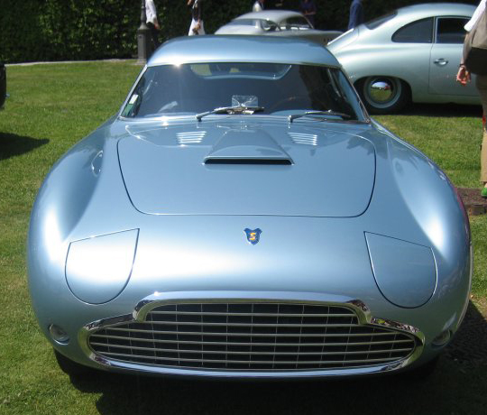

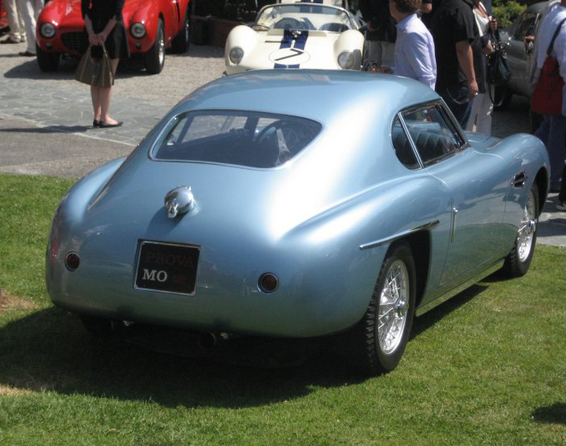

One should never be desperate: There is a future even for completely neglected and decomposed cars found as a basket case.
By winning it’s class at the 2011 Villa d’Este Concourse d’Elegance, this beautiful Siata 208 CS Berlinetta definitely will encourage
the most desperate owner of a classic car in a ruined condition. Never say never indeed, where a will there’s a way !

I found and purchased this Siata with chassisnumber *CS-069*in the summer of 2006 from John De Boer, living in his house in
Walnut Creeck, California. John is a historian expert on Italian cars and very much into Fiat 8V’s and Siata 8V’s and by tracing
ownership of Siata’s, he had found out I was the owner of *CS-074*, a similar Siata 8V Berlinetta and the last one built in a row
of only 9 cars ever produced by the Italian coach builder Balbo of Torino. John had contacted me in 2006 and asked if I could be
interested in buying his car *CS-069* as well. He also told me how seriously the car was attacked by the elements while being
laid down for so many years on a scrapyard beside a river on the US East Coast. Impossible to buy such a car wreck unseen, so
a meeting was planned for inspection.

Here’s what I found:

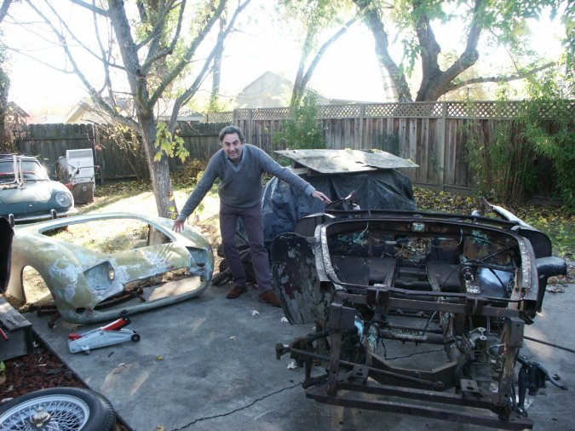

John certainly had not miss described the car: The car was completely dismantled, the body was taken off the chassis and had
been cut in 4 pieces. The parts were all over the place and apparently his garden had been the ideal “outside storage place” as it
was sitting in company of some other ‘spiritual relatives’.

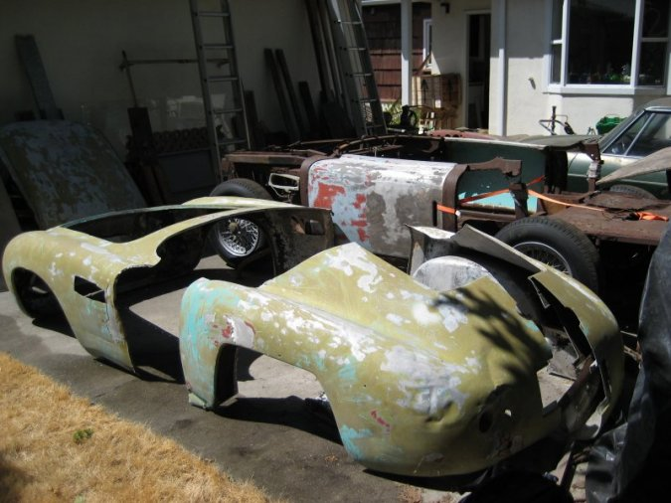

The roof had been cut off and the rear part was cut in two half parts. The body had been completely dismantled

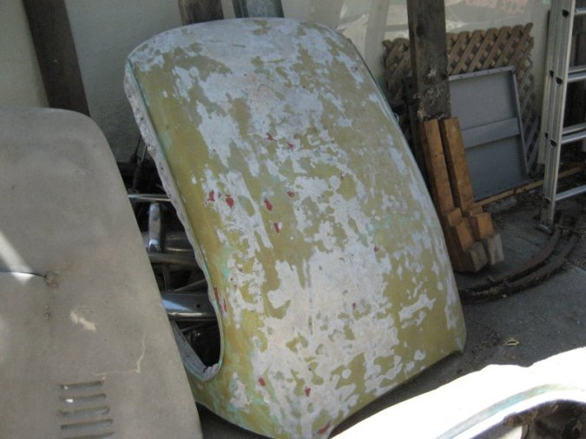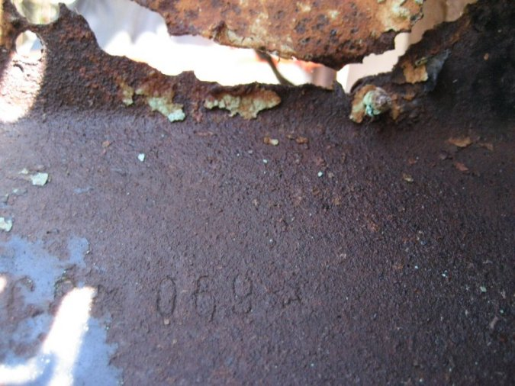

Roof and bonnet were resting against a wall The chassis number stamped in the rusty fire wall

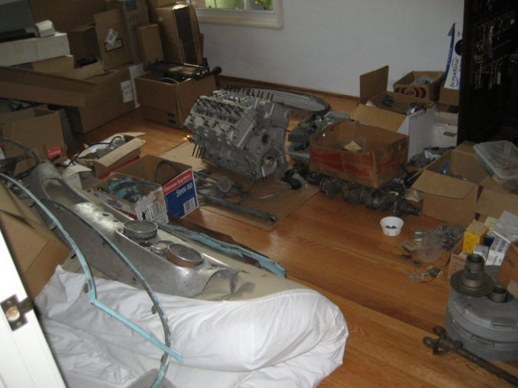

All the mechanical parts were stored inside. The ideal place here was the guest bedroom. Bits and pieces all over the place…

Although it all looked like a whole mess, I was interested and a deal was concluded, my motivation being inspired by the fact that
I owned *CS-074* in good condition and that it would serve as an excellent model to restore this wreck. For practical reasons in
respect with transport and shipping, a quick ‘restoration’ was set up:

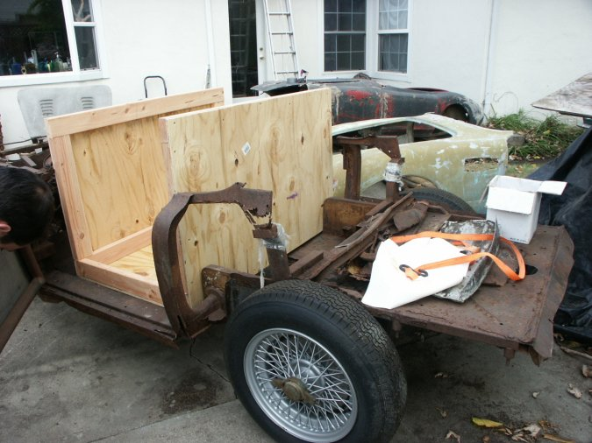

Suspension and wheels were put on the chassis to make the car transportable, and a wooden crate was ‘tailor made’ and fitted to
the chassis frame so it could be filled up with the mechanical parts. The chassis frame was in need of very serious care with a lot
of rust to be taken care of and replaced, and the complete sub frame needed to be reconstructed.

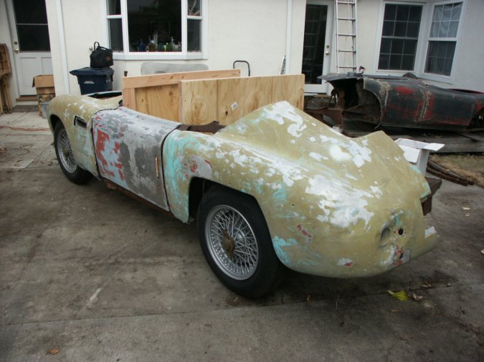

Once the crate fitted and filled up, it served as a new sub frame and the body was reassembled around it and fixed together.

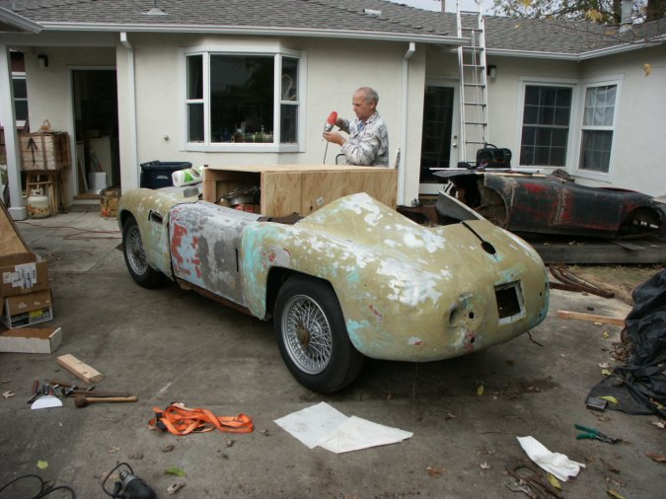

Here is John De Boer in action, closing and fixing the crate with the necessary screws.

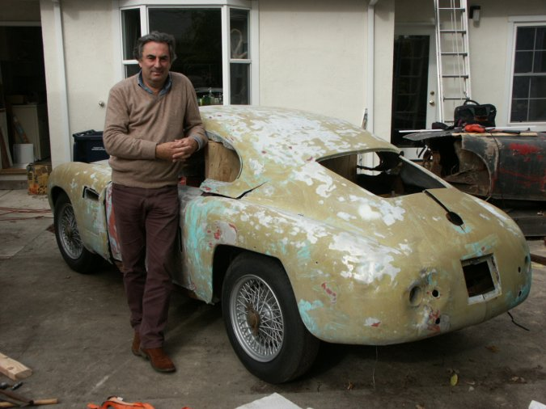

And here am I satisfied with the result of the temporary restoration : ready to be shipped to Belgium. But another problem arose !

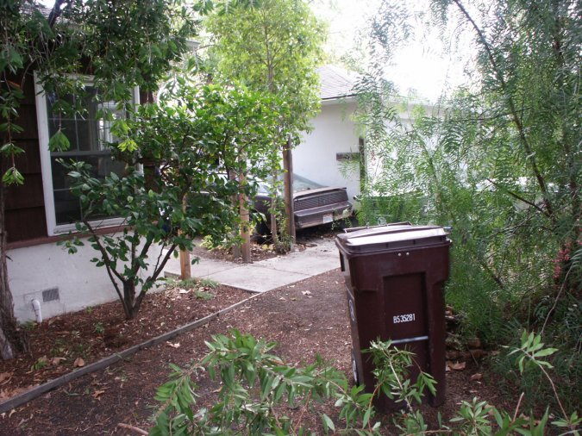

John had blocked the entrance to his garden with an old American muscle car. This was his security system and theft prevention.
But the car had been sitting for quite a while and he was unable to move it.

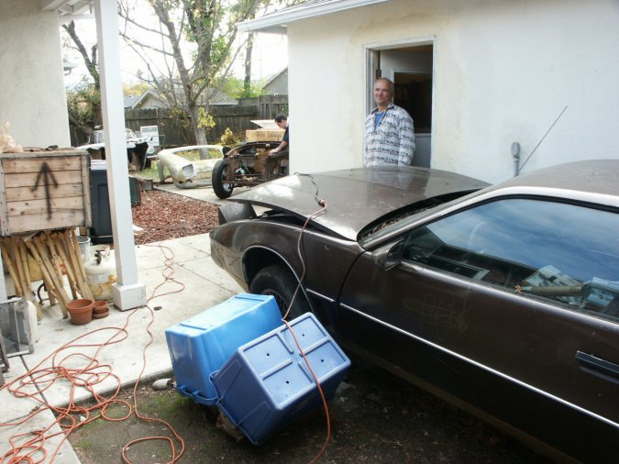

No it wasn’t the battery that failed, but the starter motor had given up. John had to buy a new one to get the car moved .. and
spent almost half a day to get it working. It appeared to be an excellent anti-theft system indeed. John took the Siata on his trailer
and delivered it to the docks in Oakland, where I had it shipped into Belgium.

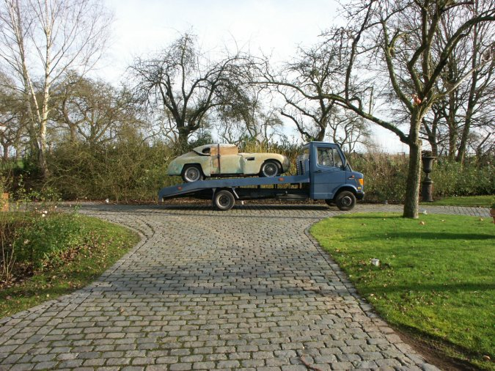

So here is *CS-069* arriving from the docks in Antwerp and being delivered to my home. We are around Christmas 2006 now.

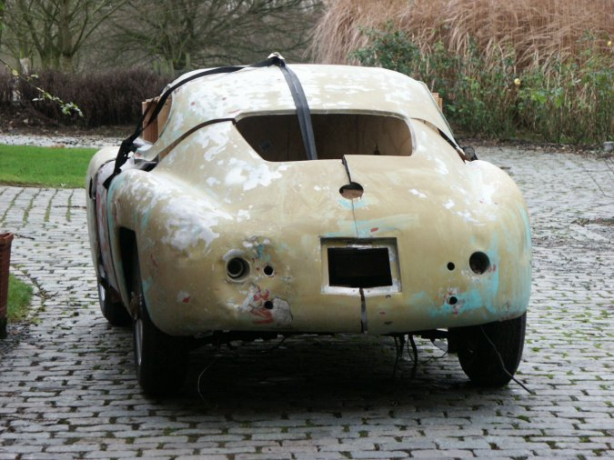

So after spending it’s entire life in the USA in , the car came back to Europe, definitely to make a start in a new life

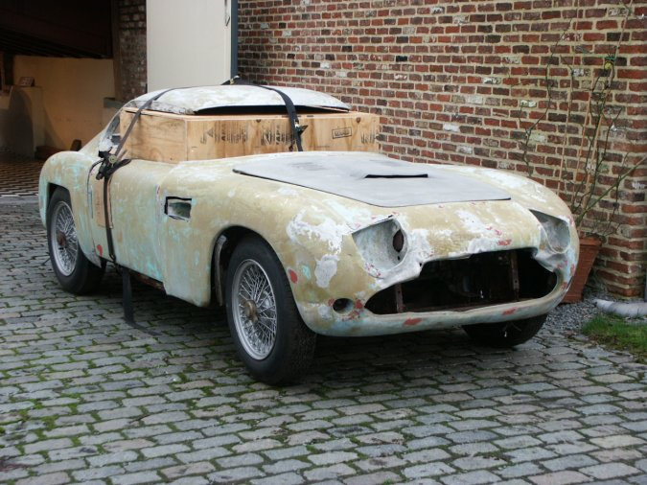

A few pictures of the car in all it’s glory

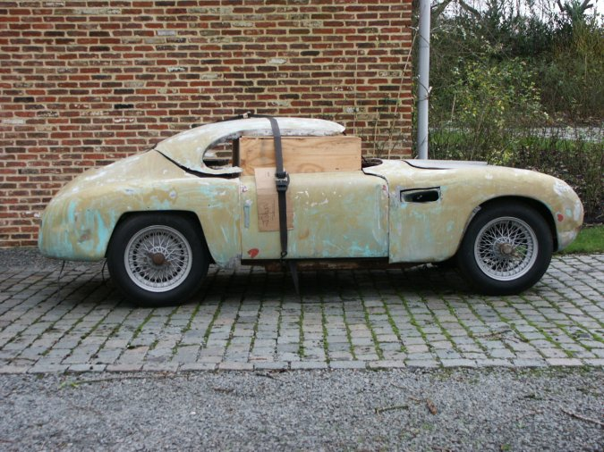

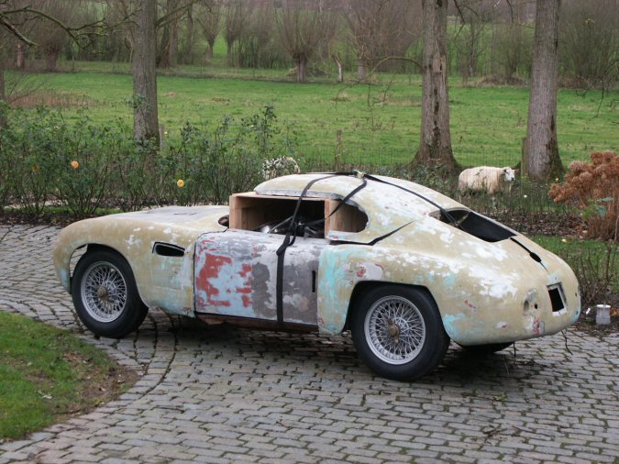

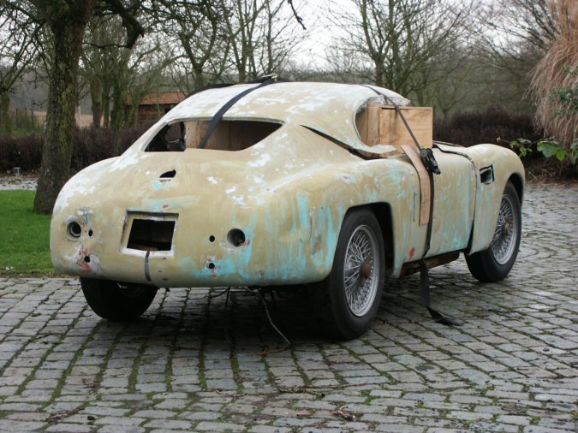

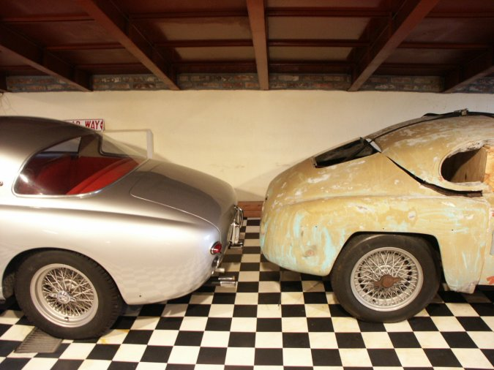

The car sitting in excellent company and safely inside.

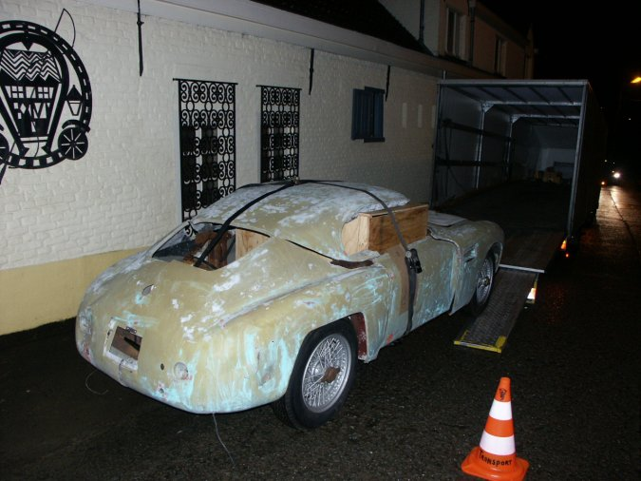

I sold the car to a Belgian enthusiast who fell in love at first sight with the model when he saw my Siata *CS-074* A Swiss restorer
of Neûchatel was contacted, but he appeared to be more a hot air balloon with many - but just only – promises.
The car was finally shipped to Quality Cars of Vigonza (Padova) in Italy for full rebuilt. They performed an really amazing
restoration of the chassis, body and components, the interior and electrical equipment. Luigino and Walter, the two managing
owners of Quality Cars have surrounded themselves with the best qualified people and perform with top results. In this case and
for the first outing, the car took best in class at the Villa d’Este Concourse d’Elegance, a great and fantastic result.

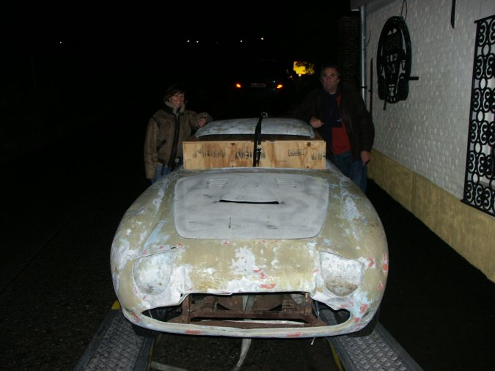

Leaving as a thief in the night, but only to come back as a victor of concourses.

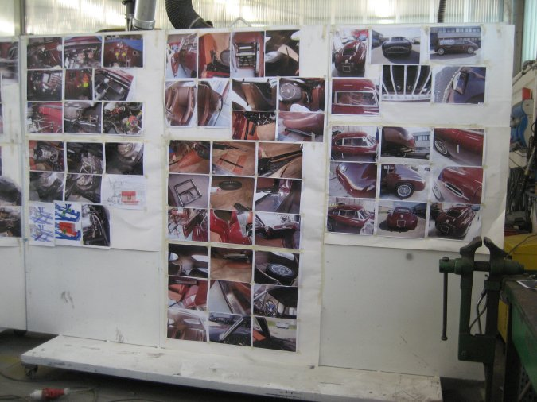

Pictures of *CS-074* as a model on the walls of Quality Cars workshop, serving as a guide in the restoration of *CS-069*

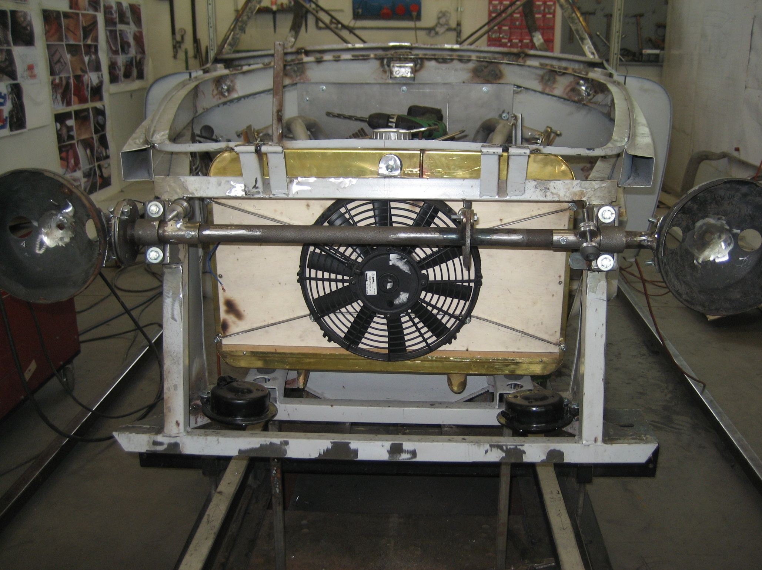

The car at Quality Cars with the sub frame already reconstructed – here still a long way to go..

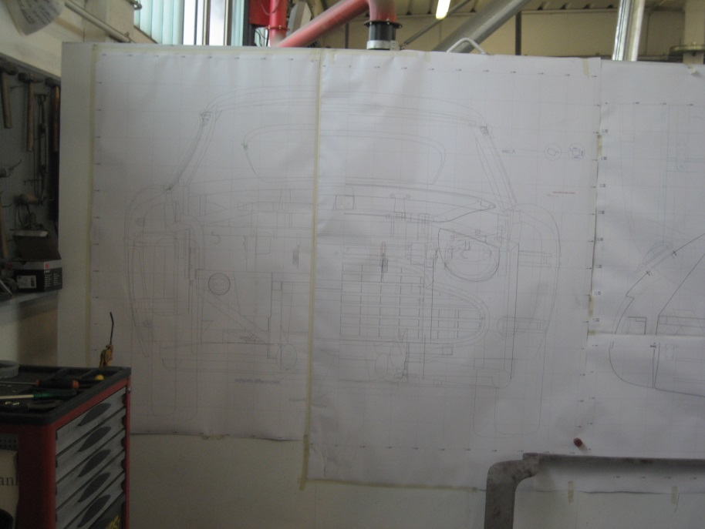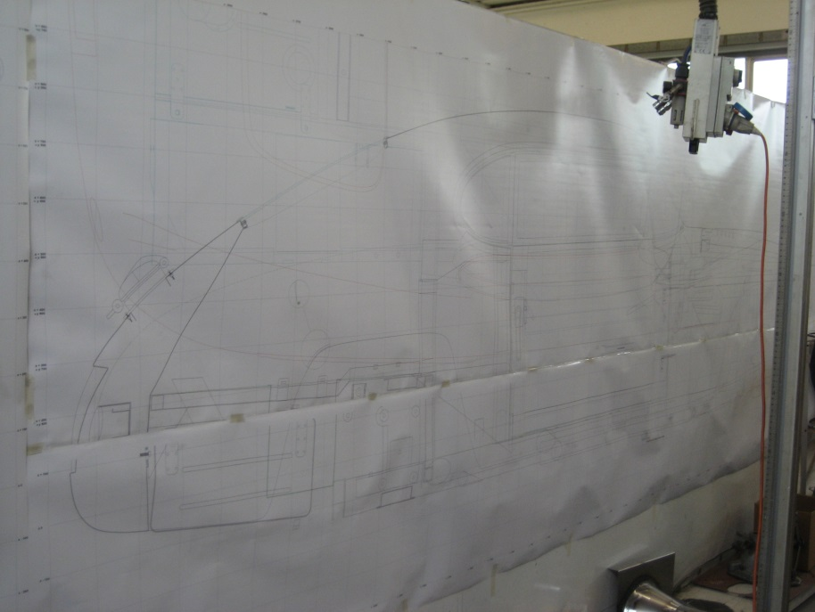

The original factory drawings have definitely helped rebuilding the car

This is an story of the resurrection of a magnificent sports car. Author of the Fiat/Siata 8V book, Tony Adriaensens questioned
the car and doubted if it was still restorable (page 835 OttoVu Siata derivata Fiat). Today’s history proves that with the right people
in place nothing seems to be impossible. It is a matter of guts and courage, intention and motivation and the will to get there.
And last but not least: the skills of the performers. Fortunately they were all there and a magnificent car is being rescued and
saved for the future.

BACK IN TIME: THE EARLY DAYS OF *CS-069*

The early history of *CS-069* is one of racing on the East Coast tracks in the United States. In June 1955 during an Airport race
in New Bedford, Massachuses, George Arents was racing the Siata and blew up the original V8 engine somewhere in the last turn
and before the pits.
At that time, a Ferrari 4 cylinder 2 liter engine was purchased from Jim Pauley and fitted into the car. Arents testified that he had
some wonderful racing experience with that engine in the Siata, although he found it a little ‘too heavy’. But the fast cornering
capabilities of the car compensated a lot, he said.

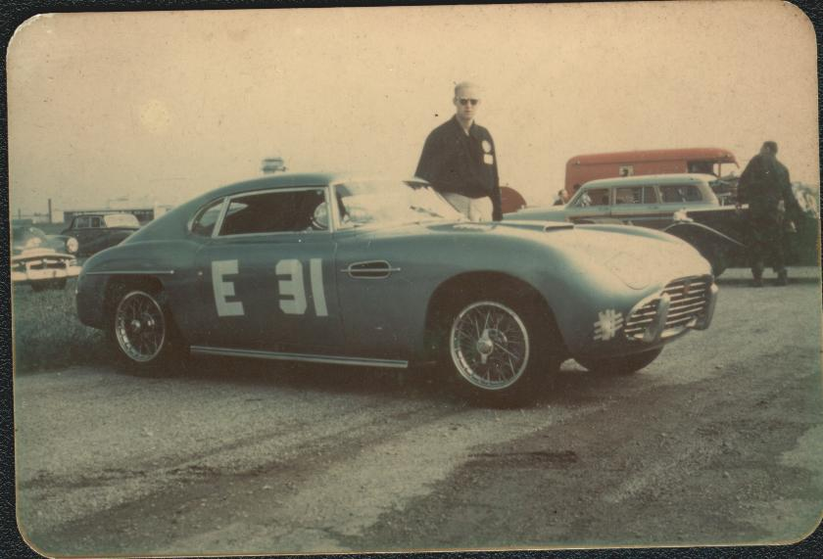

In 1957 George Arents sold the car to a young enthusiast of Charlotte, North Carolina. It is known that this man fitted a Jaguar
4 speed gearbox into the Siata, after the original 5 speed must have lost all of its functions due to heavy racing.

In the early to mid-seventies, the car was discovered by Gary Schonwald, of Scotch Plns, N.J. moving later into New York.
When I purchased the car from John, the title was still in his name; see the copy here under.

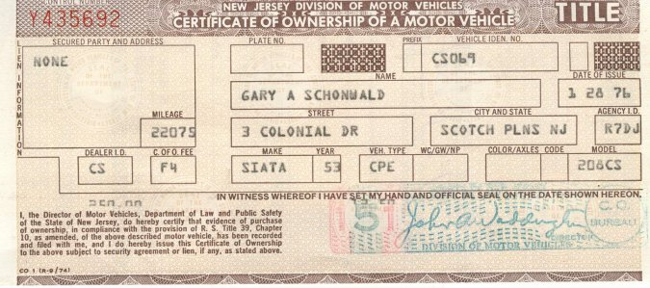

Schonwald made some timid attempts to reassemble parts for the car but finally the car was sold in 1979 to John O’Donnell of
New Jersey.
At that time , the car was still ‘partly together, but missing its original engine and transmission. Here are pictures taken in 1979:

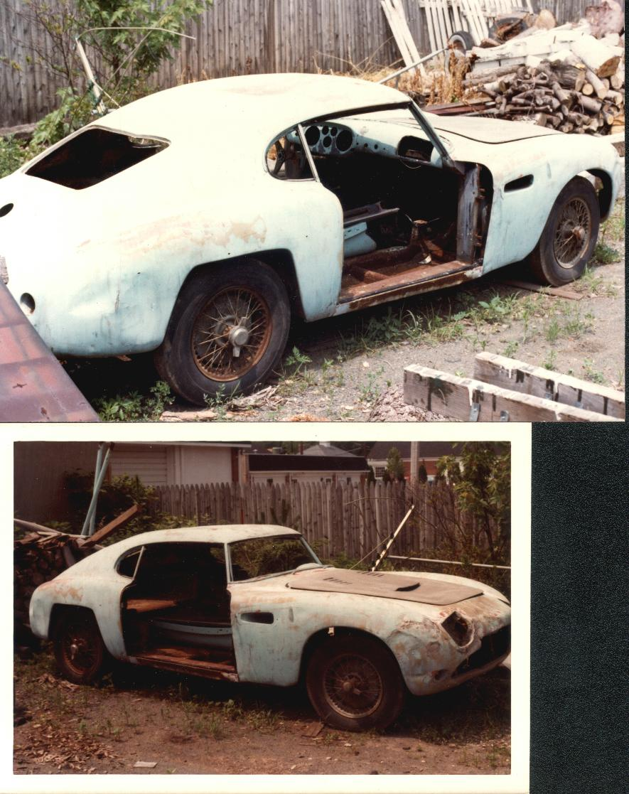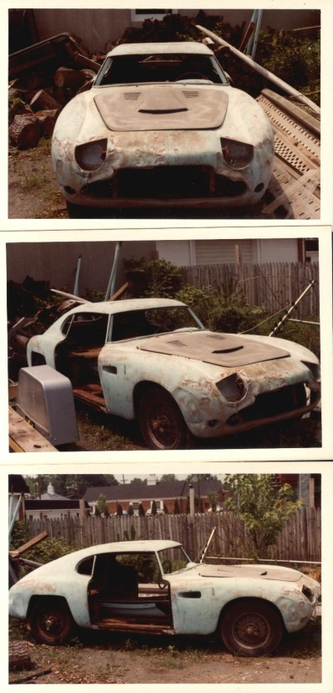

In a letter to John De Boer, O’Donnell writes that people took him for crazy as the car was ready for the crusher. It was not only
missing all its mechanical components, but also the glass, the interior, the instruments etc…
Meanwhile he had started taking the car apart ‘for restoration’ and he taught he was at ‘ a point of no return’. See the photos:

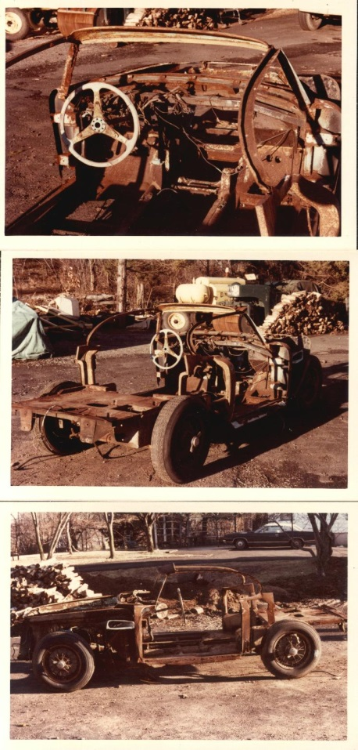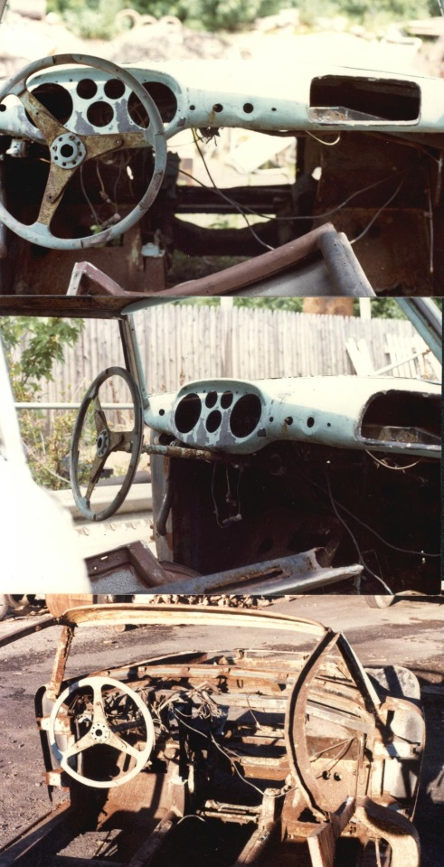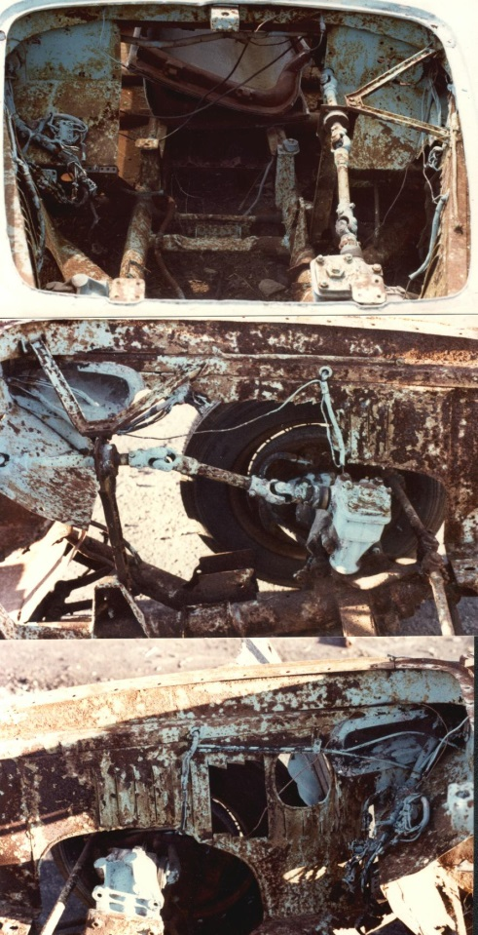

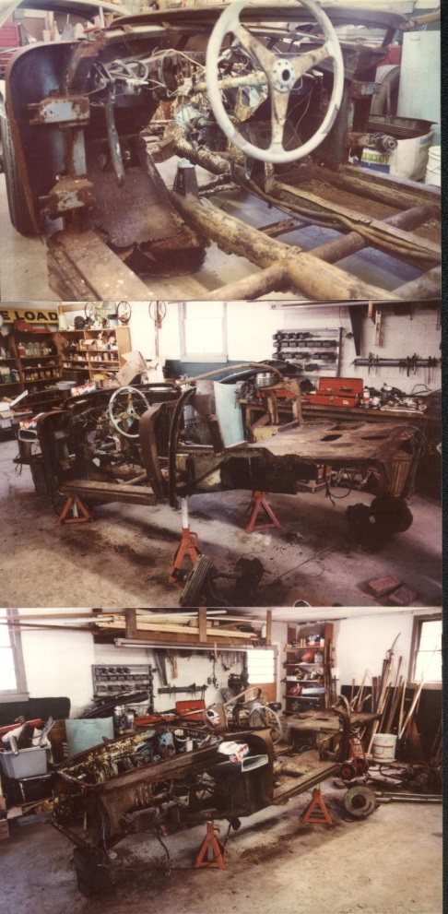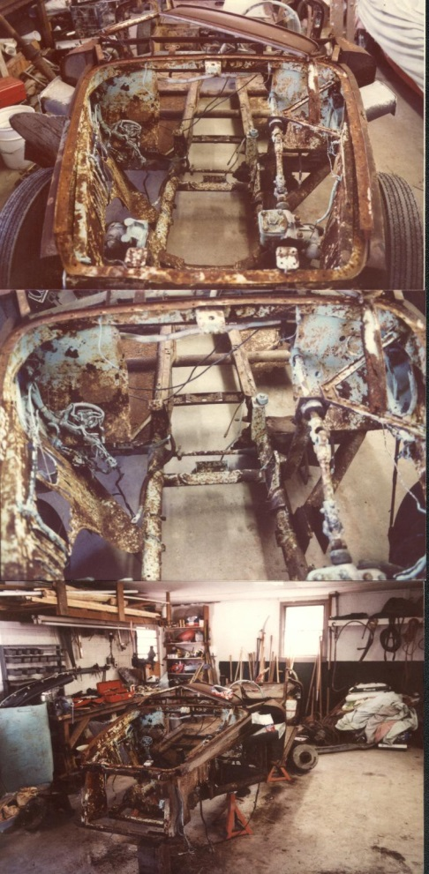

In his letter he asked John if he was willing to sell the parts he already had collected. This did not happen, but the other way
around and many years later, John De Boer purchased the remains of the car, and re-united a maximum of spare parts, including
the original engine. The original 5 speed gearbox was destroyed and lost, but a similar one was found. The car was still missing
some vital parts, but with good research most have been located so the restoration was brought to a real happy end…

